**Project Report Template**

**Salesforce Introduction:**

Salesforce is a customer success platform , design helps to sale , service , market , analyze and connect with our customers . running business from anywhere with Salesforce . use standard products and features to manage relationship with prospects and customers , collaborate and engage with employees and partners , and store a data securely in the cloud.

Salesforce is world leading CRM platform that caters to need of over 150,000 clients of all business domains and sizes. If offers 20 off-the-shelf CRM suites called “clouds” that focus on various needs and industries. Among the most popular ones are sales cloud , service cloud , and marketing cloud.

As a CRM industry leader, Salesforce tries to fulfill the basic demands for the software of any business. And over 2,000 Salesforce consulting partners are to weak the system to every tiny business request.

###### Introduction:

###### Companies or organizations mainly provide business travel. Business travel primarily aims to meet new people and crack deals to enhance the business’s growth. This is also beneficial for developing a relationship with the stakeholders. Business travel also helps to understand the business culture of different places.

###### This blog will discuss the advantages and disadvantages of[business travel](https://stoneberry.in/top-destinations-in-india-for-business-travel/" \t "https://stoneberry.in/what-are-the-advantages-and-disadvantages-of-business-travel/_blank). So, this blog will be appropriate if you work in an organization and want to travel for business purposes.

###### There are a few advantages of business travel which are discussed below.

**Empathy map**

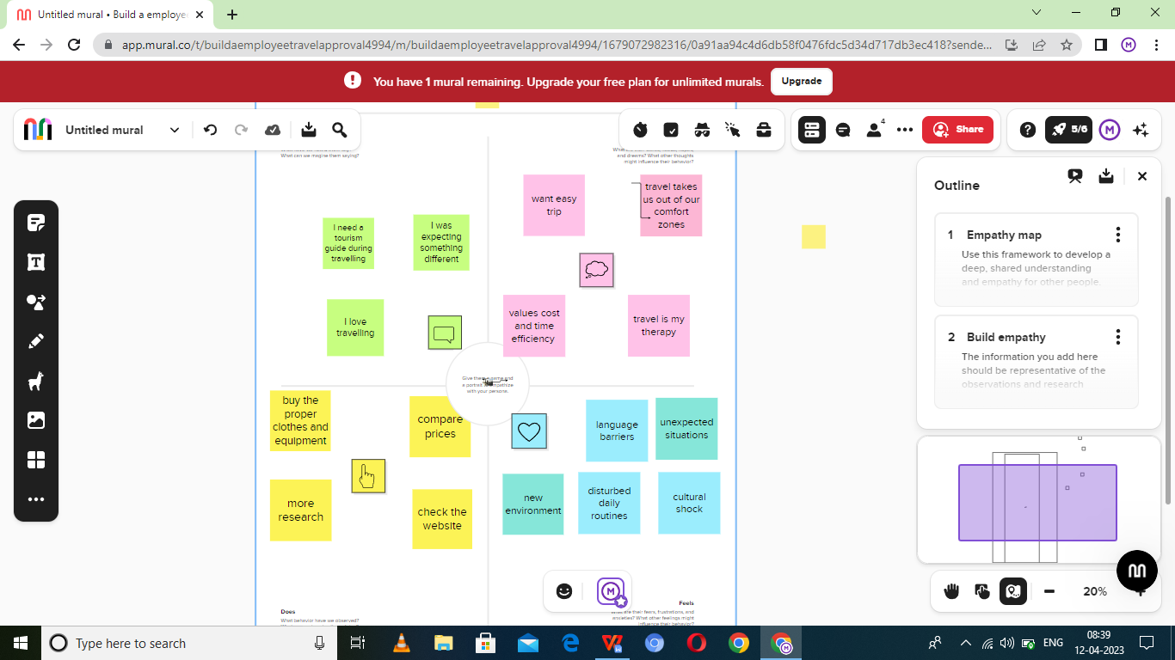

**Ideation and brainstorming map screenshot:**

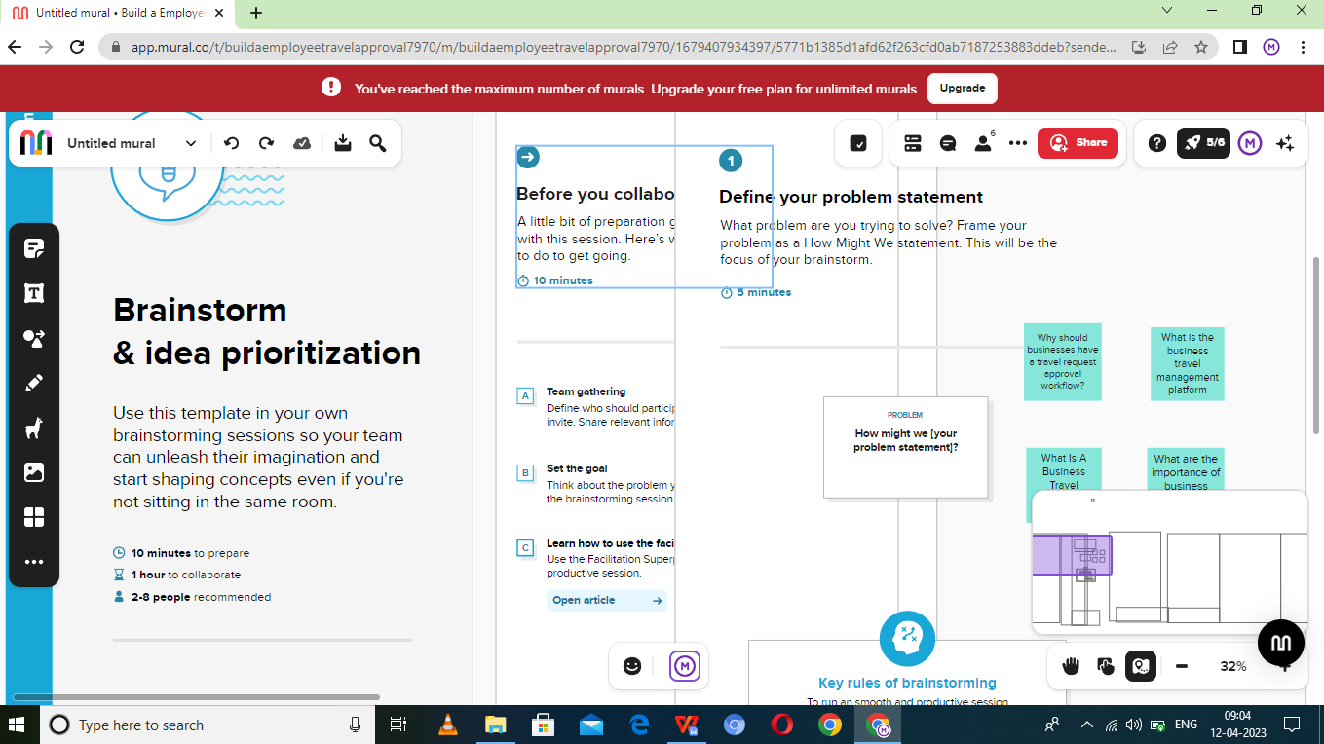

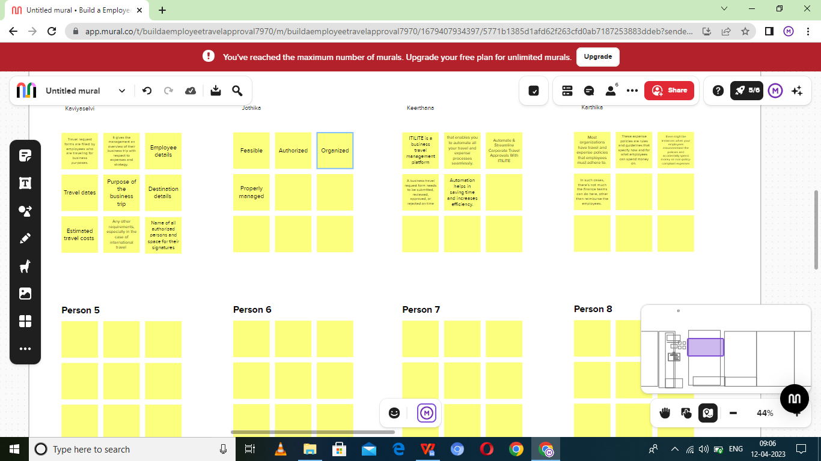

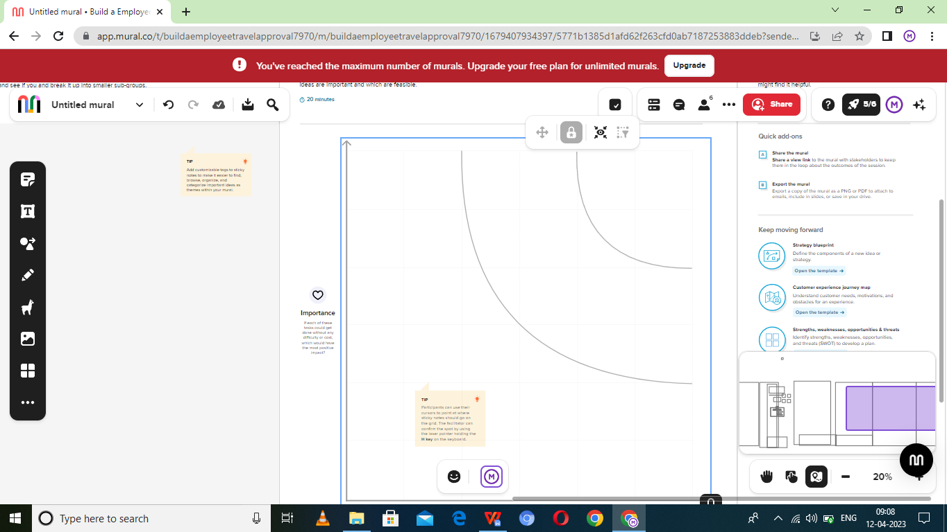

**Result:**

|  |  |
| --- | --- |
| **Object name** | **Fields in the object** |
| Object 1 | Field lable: target close date  Data: date |
| Object 2 | Field lable: contact  Data:lookup (contact) |
| Object 3 | Field lable:offer name  Data:auto number |

**Activity and screenshot:**

**Create Salesforce Org-creating developer account**

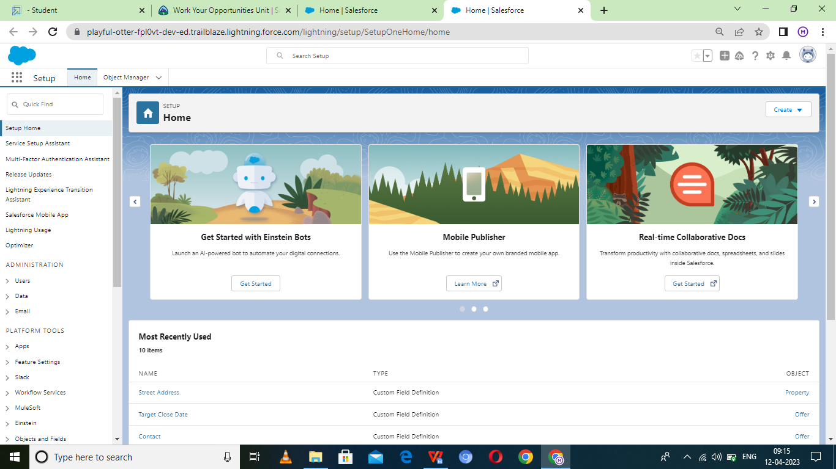

**Creation of offer object:**

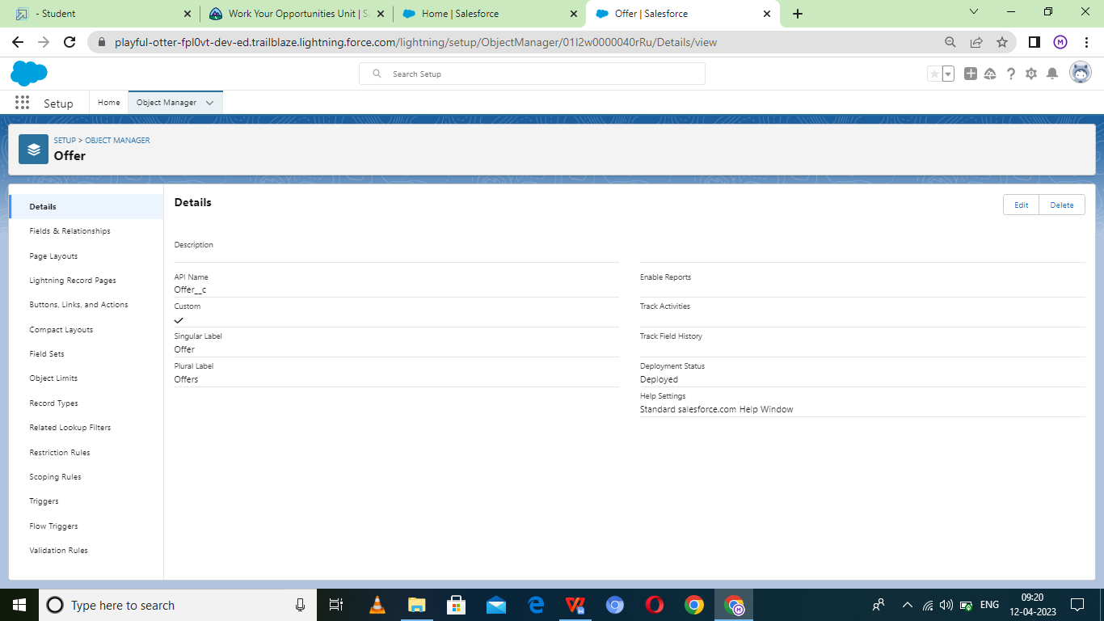

**Creation of property object:**

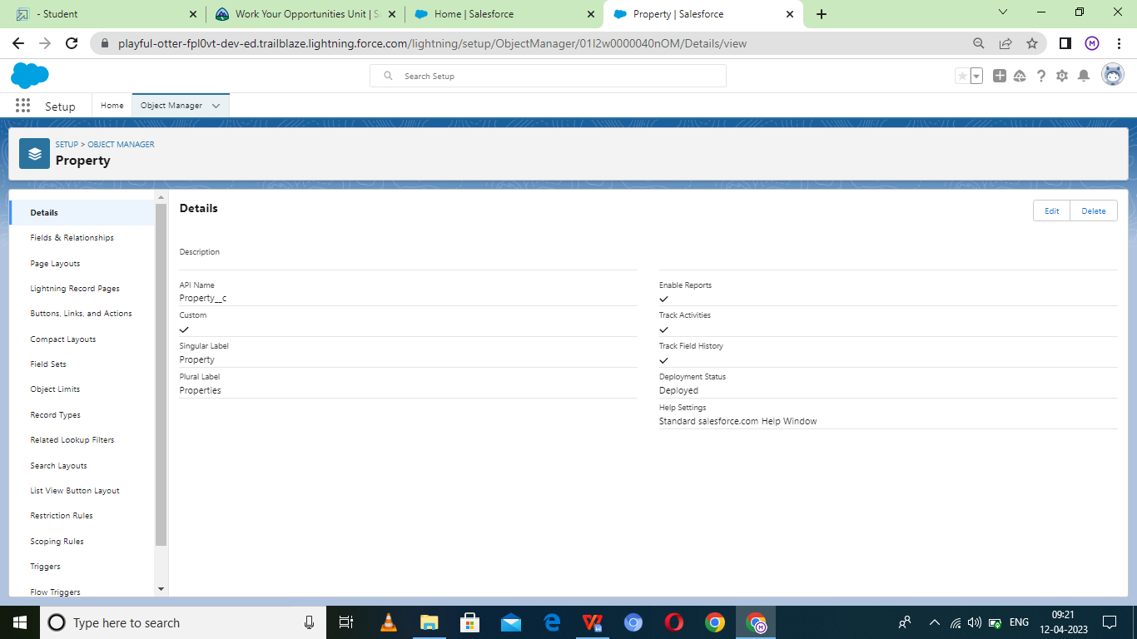

**Lighting app**

**Create the sales app**

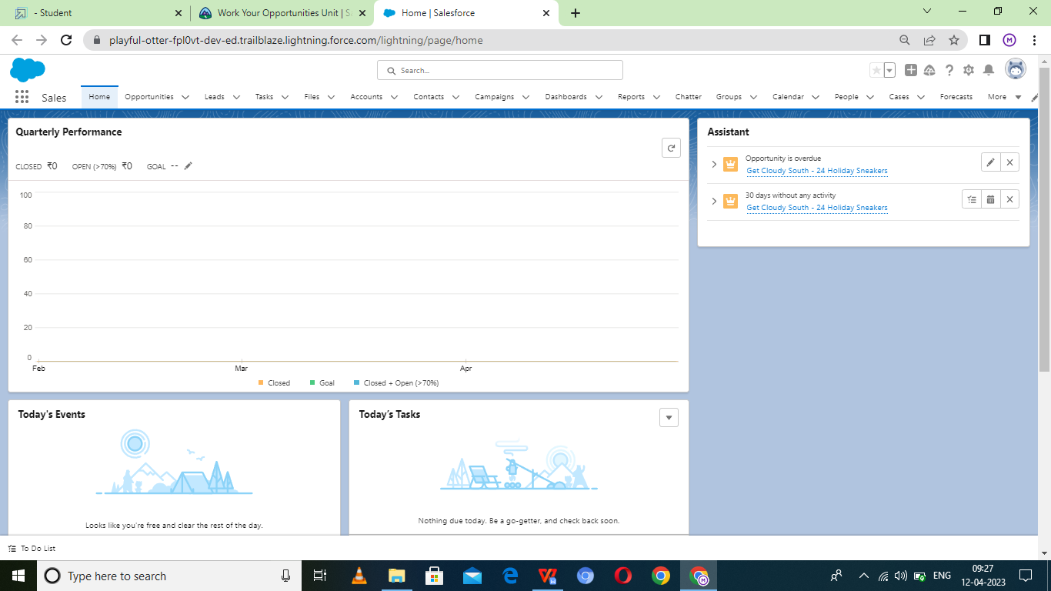

**Field and relationship**

**Creation field for the offer**

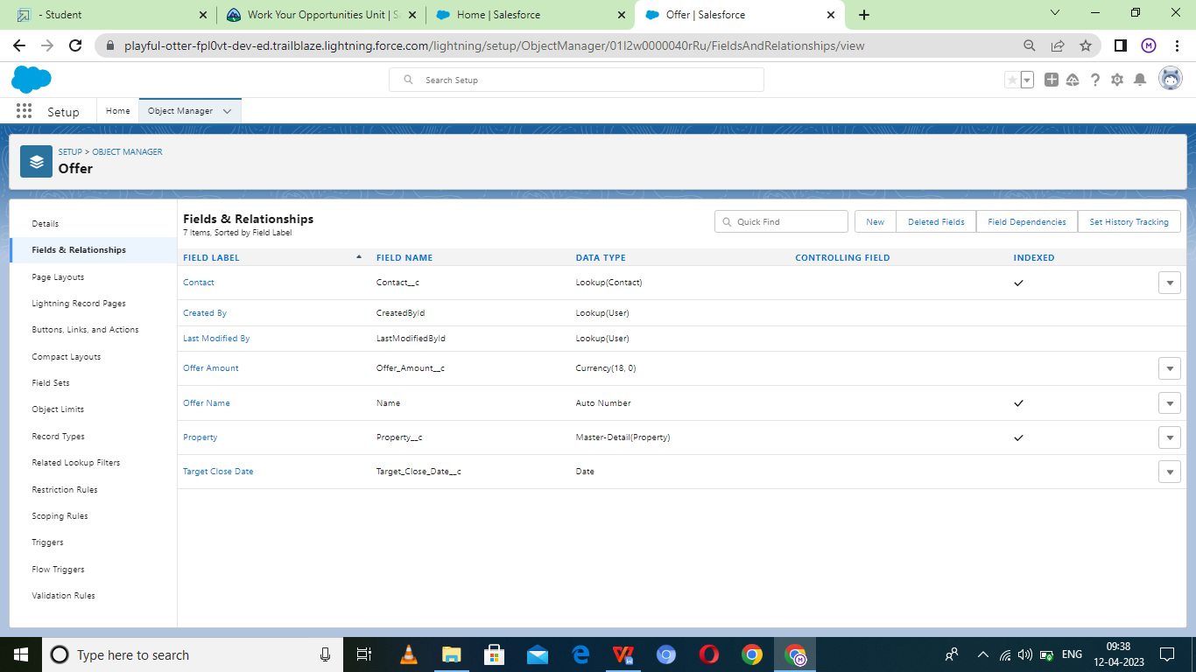

**Creation of field for the property object**

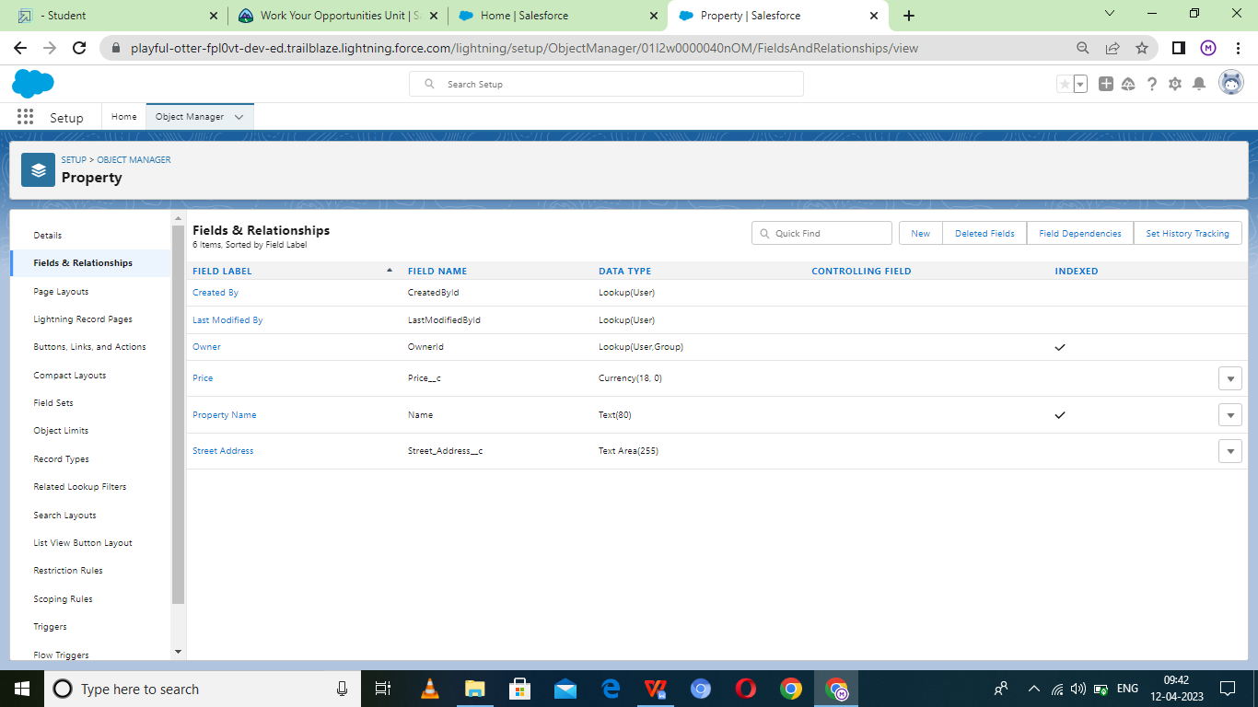

**Profile**

**Creation on profile**

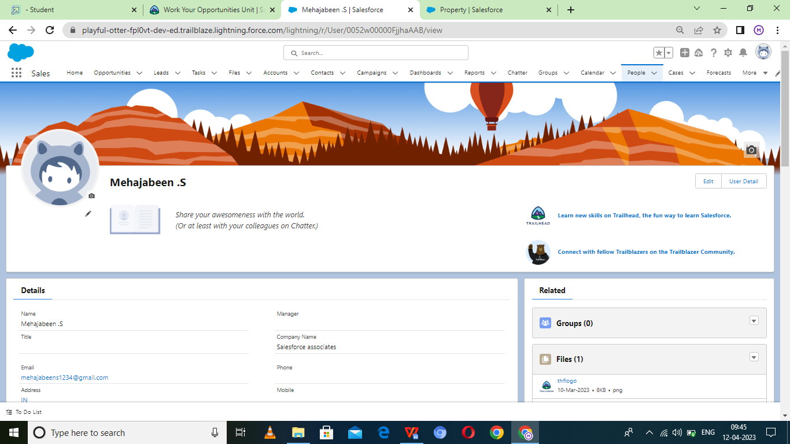

**Permission sets**

**Permission 1**

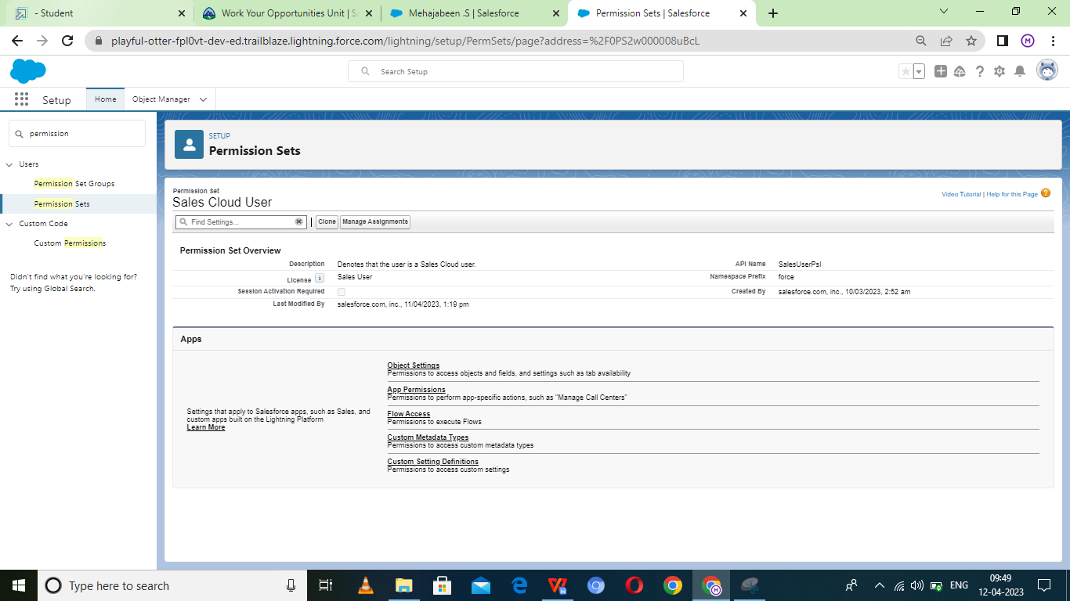

**Permission 2**

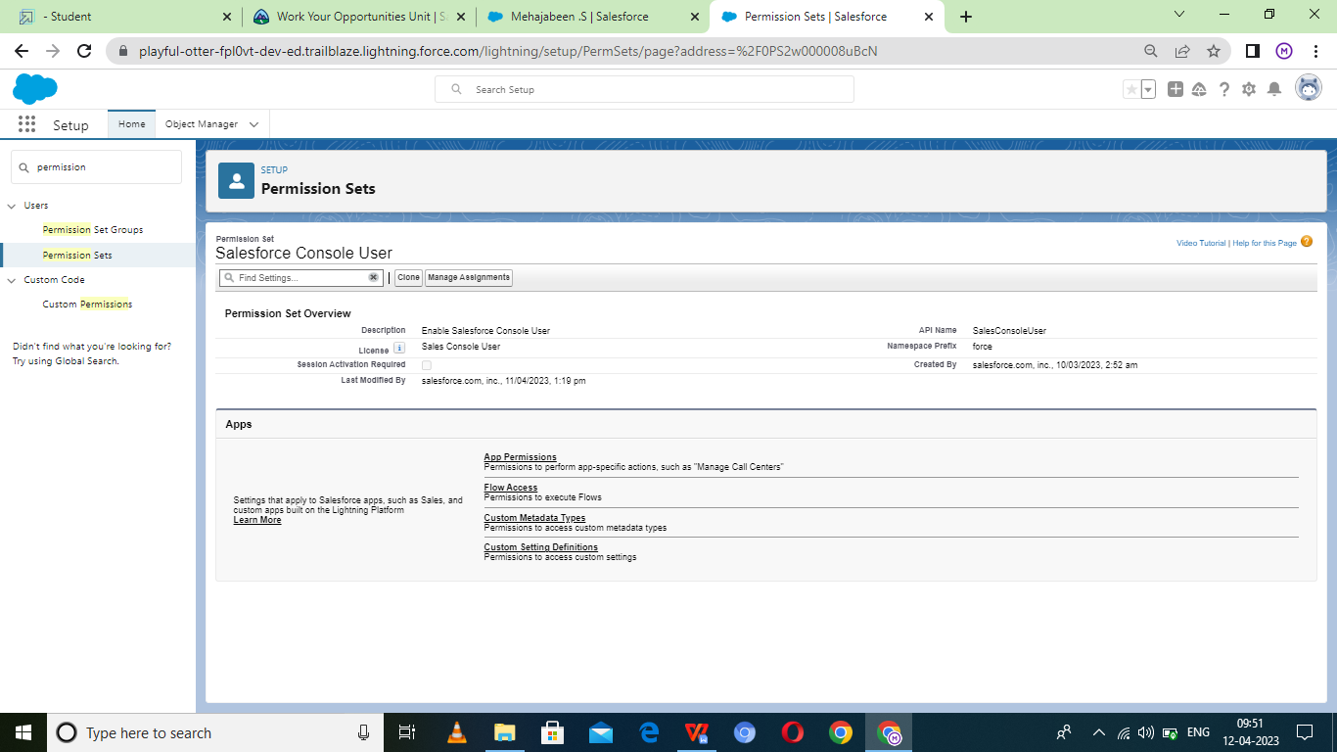

**Reports**

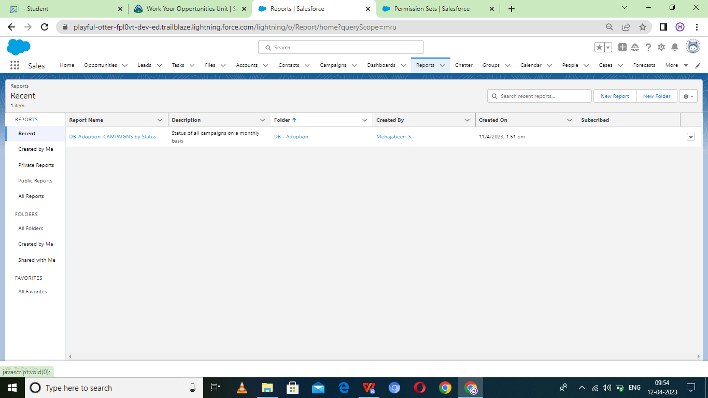

**trailhead profile public URL**

Team Lead- <https://trailblazer.me/id/meha1234>

Team member 1- <https://trailblazer.me/id/jsanthosh6>

Team member 2- <https://trailblazer.me/id/ranem>

Team member 3- <https://trailblazer.me/id/rrogini>

##### **Advantage and disadvantages: Advantages of business travel**

##### **Getting to know new people :**

##### Meeting new people is a significant advantage of business travel because it helps to understand the business-related perspective of the people. Because of this, people can also develop creativity in business organizations. Apart from this, it allows an understanding of the place’s culture. The face-to-face interaction will also improve to enhance the business network.

##### **Build a confidence :**

##### In order to build confidence, you need to come out of your comfort zone. This is beneficial for developing communication skills. Because of this, you can easily interact with people. When your confidence level increases, we can solve your problems. Moreover, it will also be beneficial for enhancing problem-solving problem-solving skills.

##### **To get the Experience of new places :**

##### This is another advantage of business travel. It helps to adapt to new things from the place, such as the culture of the business. The various types of places follow various types of [business cultures](https://medium.com/@stoneberry432/top-10-restaurants-in-ranchi-bdfbcb3b1aff" \t "https://stoneberry.in/what-are-the-advantages-and-disadvantages-of-business-travel/_blank), which can help the organization reach the desired goals. This is also good for breaking the monotony of the work because meeting with new people and exploring new places will be helpful to keep your mind fresh.

##### **Find the new places :**

##### Finding a new place and exploring the places is the central part of business travel. It helps the employees to develop the knowledge to do business operations. This also gives an impact on the productivity and growth of the organization.

##### **Disadvantage of business travel**

##### **Travel expenses :**

##### Business travels are expensive because companies spend a lot of money on it. Not only the plane ticket, but companies also provided hotel costs, transportation costs, and [food services](https://at.tumblr.com/stoneberry432/the-5-best-hotels-in-dhanbad-for-a-grand/79mbeg3cv8rt" \t "https://stoneberry.in/what-are-the-advantages-and-disadvantages-of-business-travel/_blank) to their employees. So it is evident that business travel is dependent on the tremendous amount of money of the organization. Sometimes it creates difficulty for the small startup business organization.

##### **Lack of productivity :**

##### Traveling sometimes needs help managing the time for meetings. Because of this, it has an impact on the growth of the organization. Undeniably, those who must travel for work occasionally experience a loss in productivity due to issues with the WiFi or running out of battery.

##### **It harms health and fitness :**

##### This is the principal disadvantage of business travel, and frequent traveling can be responsible for creating significant health problems for employees. Because Of this, employees can’t concentrate on their work, which affects the organization’s productivity. Additionally, consuming unhealthy food constantly can create health problems for employees.

##### **Traveling Can Be Anxious :**

##### Traveling can be stressful for you or your staff members due to missed connections, traffic, and other travel-related concerns. When you or they are under stress, it can make the journey seem ineffective. The trip’s success will be impacted by this demotivating feeling, which could also harm the organization’s growth.

**Conclusion :**

This blog concludes with the advantages and disadvantages of business travel. The primary purpose of [business travel](https://at.tumblr.com/stoneberry432/a-list-of-the-top-10-resorts-in-jharkhand-with/723dk66pxu6v" \t "https://stoneberry.in/what-are-the-advantages-and-disadvantages-of-business-travel/_blank)is to develop new ideas about business operations. On the other hand, the disadvantage of business travel is that it enhances the organization’s expense. So it may affect the growth of the organization.